The Story of our PE and Sport Premium Spend 2024-25
This year has been a successful one regarding moving our Physical Education, Physical Activity and School Sport Offer forward at Nerrols Primary School and Nursery. Below I will outline some of the ways we have used our PE and Sport Premium Funding to support these developments. At the end of my first year in the role of PE lead, I would like to share these.
Continuing Professional Development (CPD)
We have used my other role as the School Support Manager at Somerset Activity and Sports Partnership (SASP) to support staff with lesson demonstrations and team teaching on our curriculum of choice, real PE. This has been facilitated within my timetable and even though it has been a focus area for the development, we haven’t specifically used PESP funding on it.
Internal: School based Extra-Curricular Opportunities
This year we have used our funding wisely to offer a wider range of lunchtime and after school activities for our students. This has included the introduction of brand-new activities such as archery and quidditch alongside the more traditional sports of football, rugby, hockey, netball and cricket. This has increased the number of children taking part in activities as well as encouraging a wide range of children to come and have a go at something new.
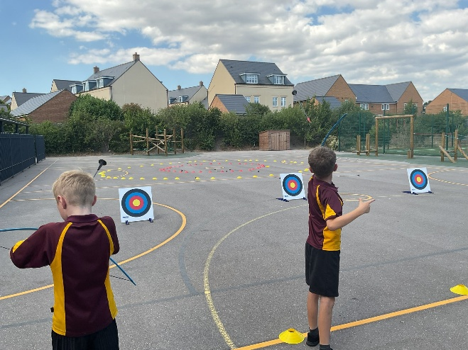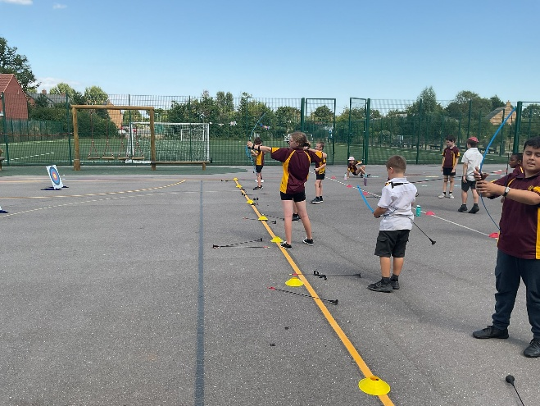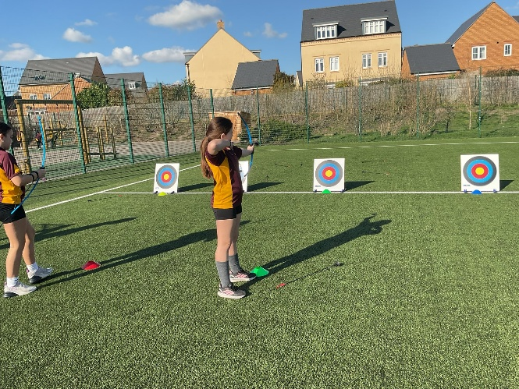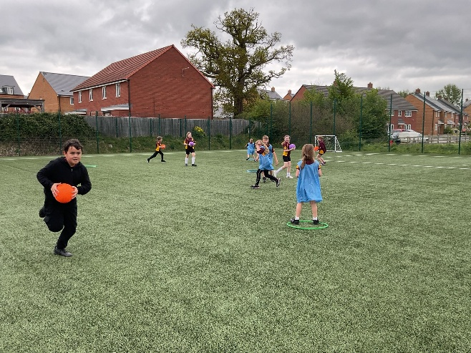
Archery and Quidditch have been our most popular after school clubs!
We have also added structured activity into our lunchtime offer with a new sport or activity played every week with different year groups. Examples have included tennis, football, cricket, golf, capture the flag, dodgeball.
We have also used music to finish each lunchtime with a wake and shake style activity that the children have enjoyed participating in.
Both initiatives have enabled us to increase participation levels at lunchtimes.
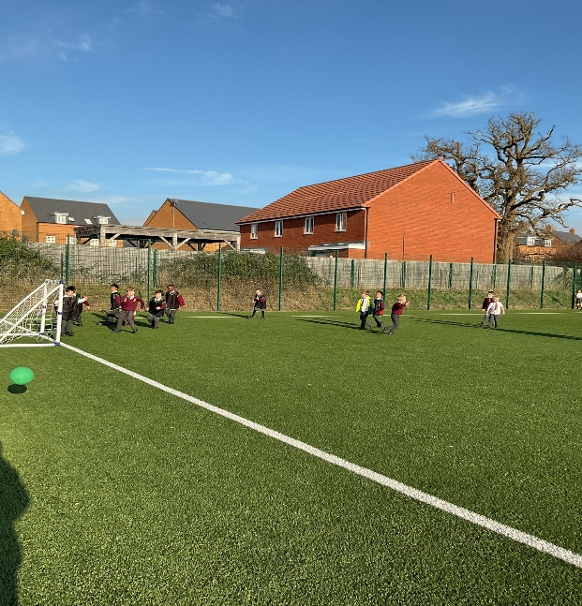
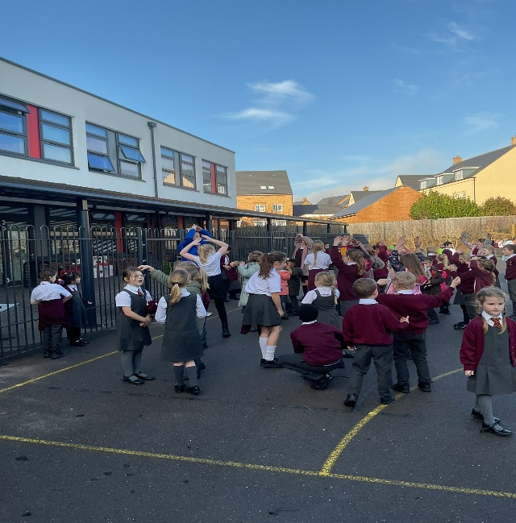
We have had a major focus on enhancing the quality of children’s play this year. This has led to us engaging with the Outdoor Play and Learning (OPAL) organisation. This has been a whole school Quality Improvement Priority and as a result, the children have been more active at lunchtimes with a wider range of activity offers from structured sports and activities to free play activities and the creation of wild areas and loose parts play den building and digging.
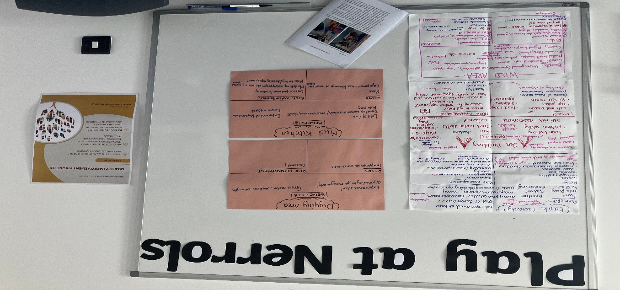
Internal Sports Competitions
This year has seen the development of intra school competition for the first time at Nerrols.
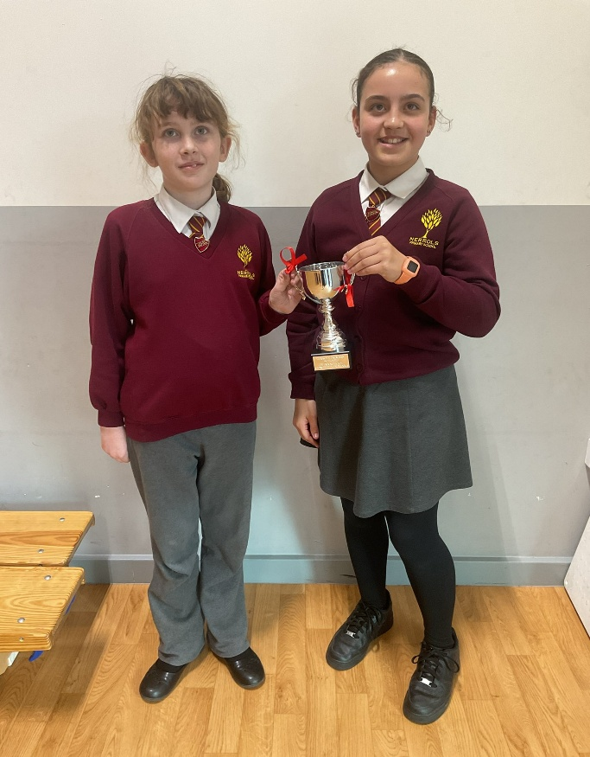
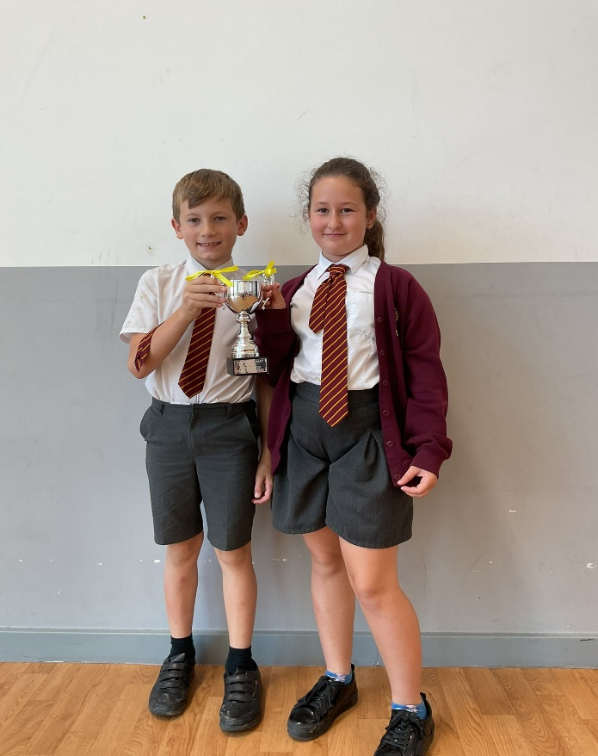
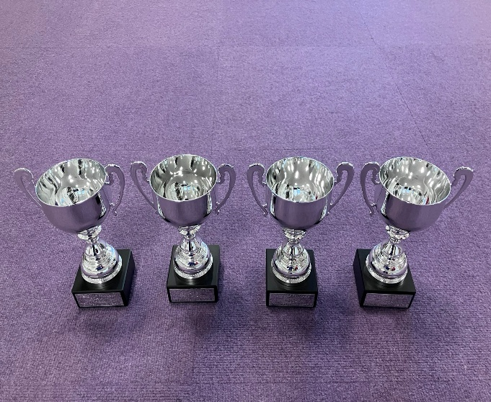
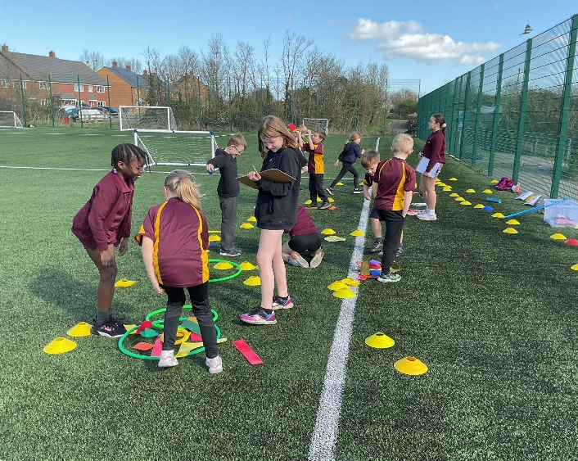
We have used funding to purchase trophies to compete for and resources for children and resources to support the activities we have done. As a result of this, all classes in KS2 have experienced house competition and the School Games Values associated with this. Additionally, all classes in KS1 have experienced a multi skills festival. Both have been led by our Year 6 cohort and have led to the profile of PE and Sport being raised throughout the school.

Top Up Swimming
We have used some of our funding to support top up swimming opportunities for our Year 5 and 6 children based on the assessments that we have done. This has made some gains towards our overall swimming results, but this is an area for further development next year.
Use of Educational Platforms
We have subscribed to a year of real PE, and the support provided by this. It continues to be the curriculum that we choose for our students. Support for high quality teaching and learning has been developed internally and without use of PESP funding. Additionally, this year we have worked very hard on developing the BURSTS programme at Nerrols. This is a real PE initiative aimed at closing the gap between school and home. We have encouraged our KS1 learners and their families to download the app and be active at home. As a result, we are the top UK school for active minutes and progress with the app! 👏🏻👏🏻👏🏻
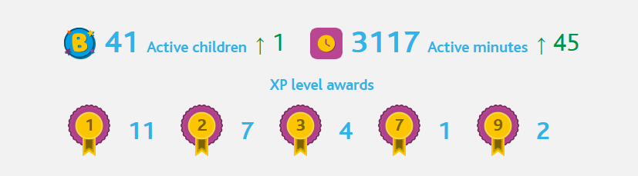
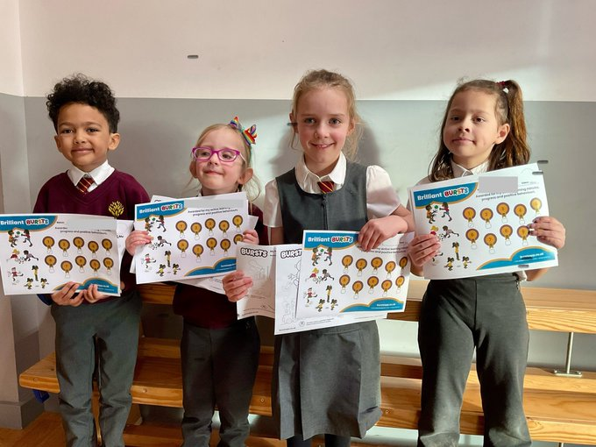
Activities Organised by School Games Organiser Network
This year we have engaged for the first time with the School Games Organisers and that has enabled us to make sure that more children are representing the school at inter school competitions and engaging with competitive sport.
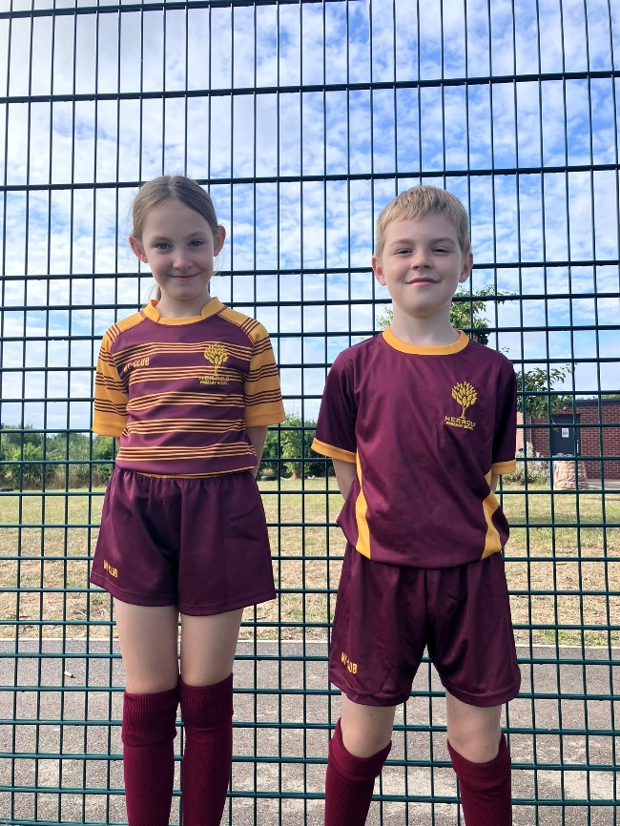
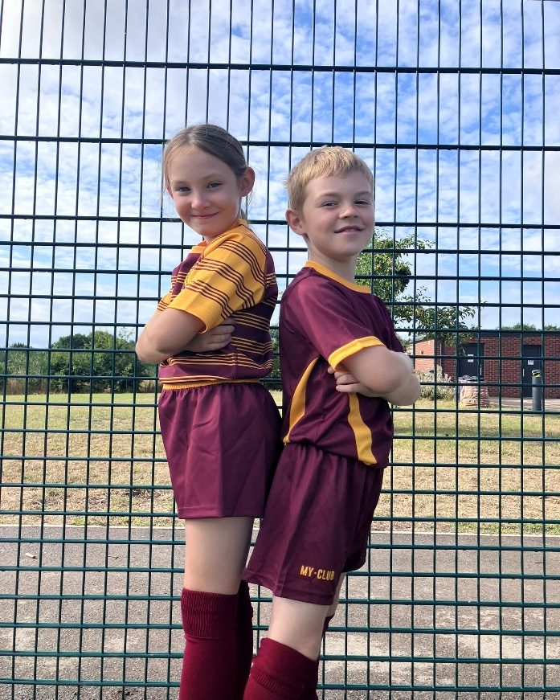
This year, children from across KS2 have represented the school in the following activities.
Rugby Cross Country Basketball
Cricket Netball Inclusive Events
Swimming Handball
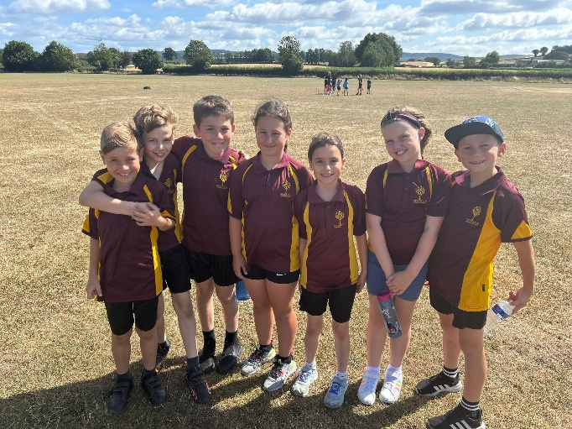
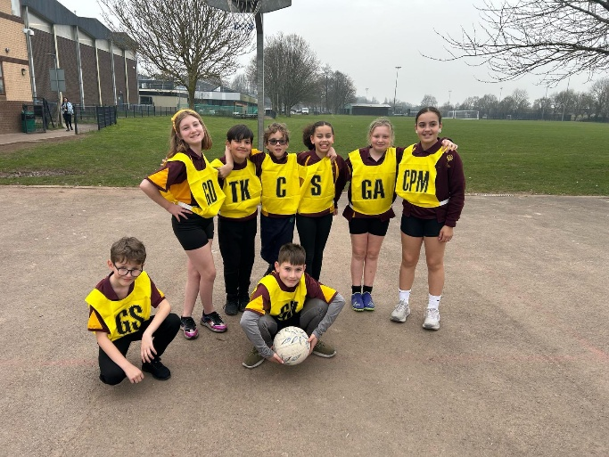
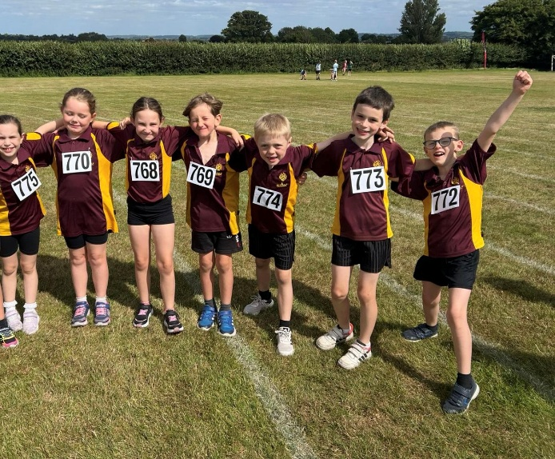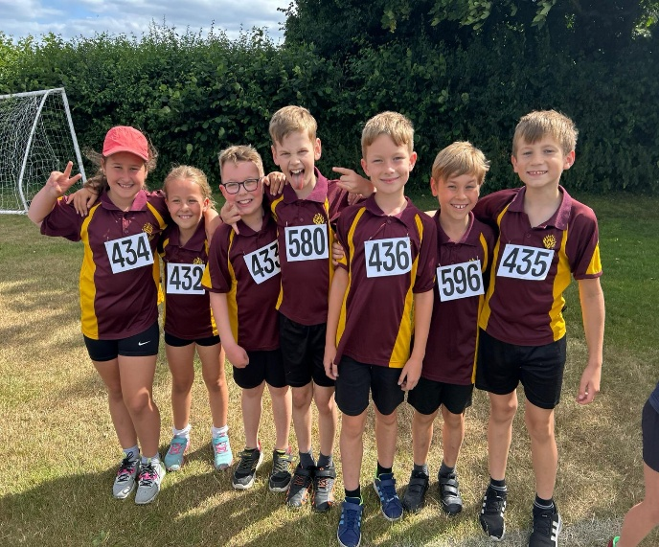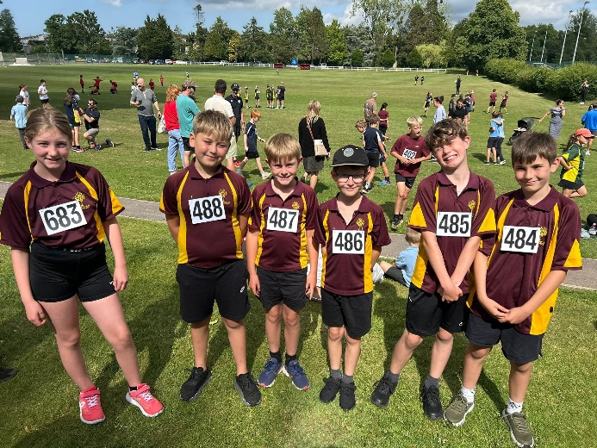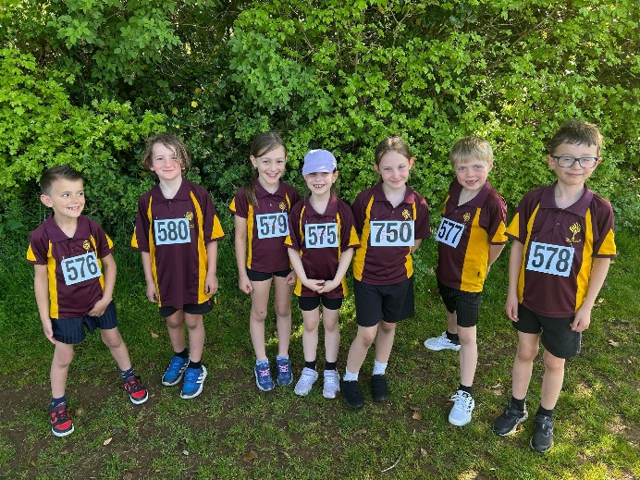

Another branch of the SGO buy in has been the leadership programme. PESP funding was used for the students to access the leadership opportunities and then put them into practice during the year. They led the intra school competition as well as the festivals for KS1 children.

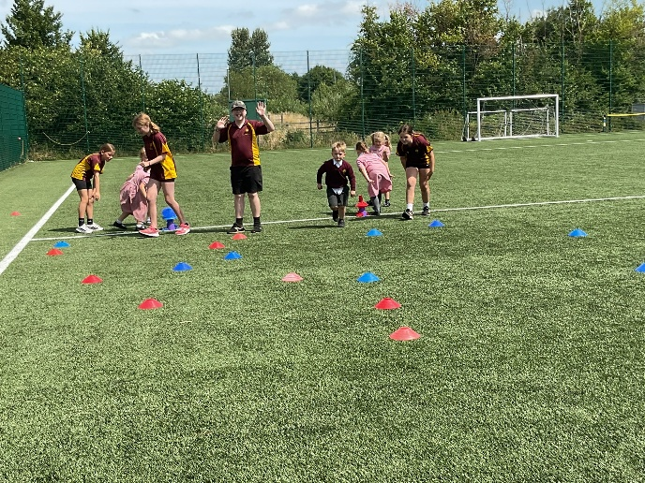
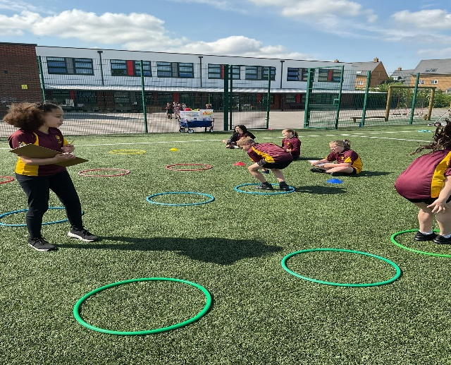
We are putting plans together for next year including the development of a ‘Change4Life’ club led by our Year 6 children aimed at encouraging target groups of students to become more active.

Mr. Templeton
@NerrolsPE

